**Project Target-SQL**

About Target:

Target is a globally renowned brand and a prominent retailer in the United States. Target makes itself a preferred shopping destination by offering outstanding value, inspiration, innovation and an exceptional guest experience that no other retailer can deliver.

This particular business case focuses on the operations of Target in Brazil and provides insightful information about 100,000 orders placed between 2016 and 2018.Analyzing this business case helps us gain valuable insights into Target’s operations in Brazil

Dataset:

<https://drive.google.com/drive/folders/1TGEc66YKbD443nslRi1bWgVd238gJCnb>

**Exploratory Analysis**:

1)Data type of all columns in the "customers" table.

SELECT column_name as col_name,data_type from `Target_Dataset.INFORMATION_SCHEMA.COLUMNS`

where table_name ="customers";

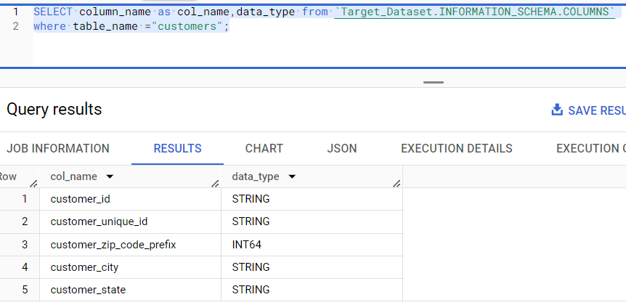

2) Get the time range between which the orders were placed.

select min(order_purchase_timestamp) as min_time ,max(order_purchase_timestamp) as max_time

from `Target_Dataset.orders`;

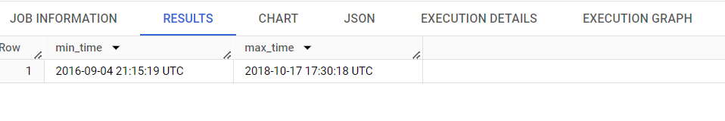

3) Count the Cities & States of customers who ordered during the given period

select c.customer_city,c.customer_state from `Target_Dataset.customers` c inner join `Target_Dataset.orders` o

on c.customer_id=o.customer_id group by 1,2;

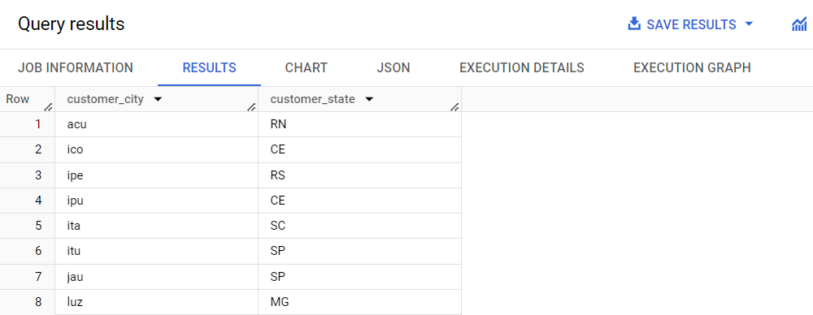

4) Is there a growing trend in the no. of orders placed over the past years?

select extract(year from order_purchase_timestamp ) as year,

extract(month from order_purchase_timestamp) as month,

count(distinct(order_id)) as count_of_orders

 from `Target_Dataset.orders`

 where order_status="delivered"

 group by 1,2 order by 2,1;

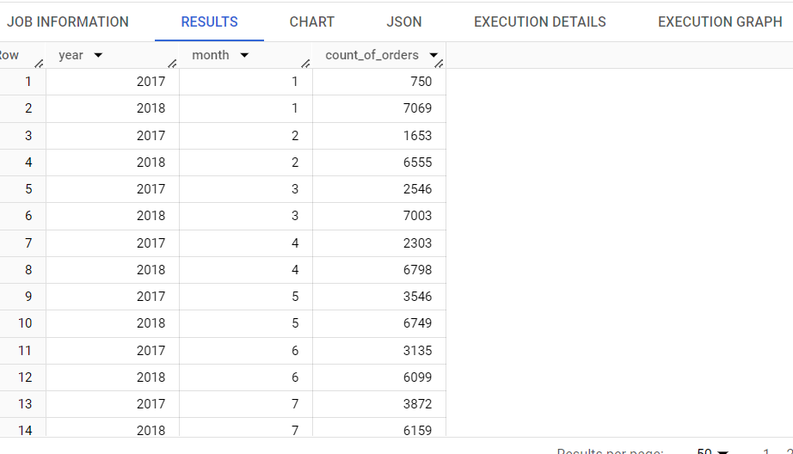

Alternate way:

You can also find out the maximum orders for every year and every month where the sales were at peak.

create view Target_Dataset.seasonality as (select extract(year from order_purchase_timestamp ) as year,

extract(month from order_purchase_timestamp) as month,

count(distinct(order_id)) as count_of_orders

 from `Target_Dataset.orders`

 where order_status="delivered"

 group by 1,2 order by 2,1);

select year,month,max(count_of_orders) as max_orders from Target_Dataset.seasonality group by year,month order by 1,2;

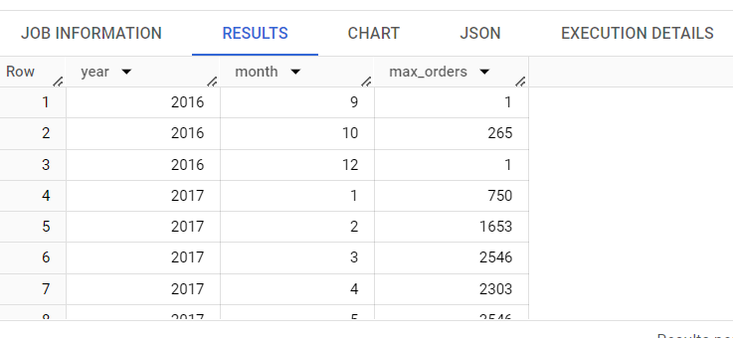

5) During what time of the day, do the Brazilian customers mostly place their orders? (Dawn, Morning, Afternoon or Night)

* 0-6 hrs : Dawn
* 7-12 hrs : Mornings
* 13-18 hrs : Afternoon
* 19-23 hrs : Night

select sum(case when hour_ between 0 and 6 then orders end) as Dawn,

sum(case when hour_ between 7 and 12 then orders end) as Mornings,

sum(case when hour_ between 13 and 18 then orders end)as Afternoon,

sum(case when hour_ between 19 and 23 then orders end)as Night

from

(select extract(hour from order_purchase_timestamp) as hour_,

count(distinct(order_id)) as orders from `Target_Dataset.orders`

where order_status="delivered" group by 1)

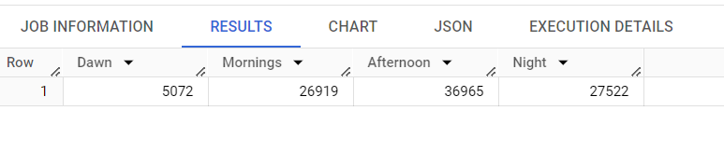

**Evolution of E-commerce orders in the Brazil region:**

1)Month on month no. of orders placed in each state.

select  c.customer_state,extract(month from o.order_purchase_timestamp) as month,

count(distinct(o.order_id)) as count_of_orders

 from`Target_Dataset.customers` c inner join `Target_Dataset.orders` o

on c.customer_id=o.customer_id group by 1,2 order by 1,2;

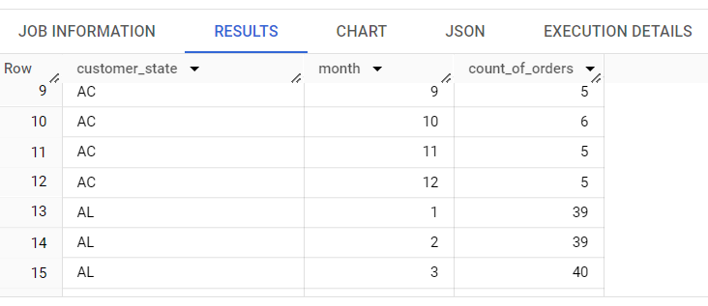

.

2) How are the customers distributed across all the states?

select count(customer_unique_id) as customer_count,customer_state from `Target_Dataset.customers`

group by 2 order by 2,1

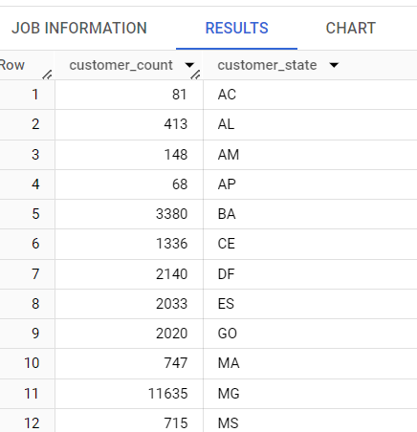

Impact on Economy: Analyze the money movement by e-commerce by looking at order prices, freight and others.

1)Get the % increase in the cost of orders from year 2017 to 2018 (include months between Jan to Aug only)

with pay as

(select extract(year from o.order_purchase_timestamp)as year,round(sum(p.payment_value),0) as payment from `Target_Dataset.payments`p inner join `Target_Dataset.orders`o

on p.order_id=o.order_id

where extract(month from o.order_purchase_timestamp) between 1 and 8

and extract(year from o.order_purchase_timestamp) between 2017 and 2018

group by 1

),

lagger as(

select *,lag(payment,1) over(order by year asc) as lg from pay)

select *,((payment-lg)/lg)*100 as percent_increase from lagger

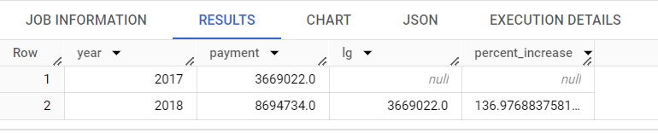

2) Calculate the Total & Average value of order price for each state.

select c.customer_state,round(sum(oi.price),1) as total_sum,round(avg(oi.price),1) as avg_price

 from

 `Target_Dataset.customers` c inner join `Target_Dataset.orders`o

on c.customer_id=o.customer_id inner join

`Target_Dataset.order_items` oi on o.order_id=oi.order_id

group by c.customer_state order by 1,2

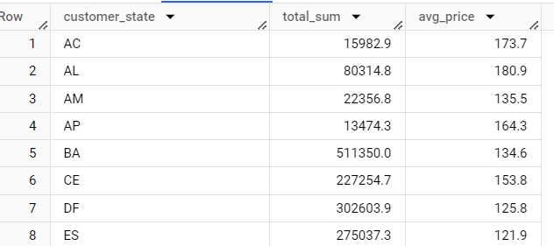

3) Calculate the Total & Average value of order freight for each state.

select c.customer_state,round(sum(oi.freight_value),1) as total_sum,round(avg(oi.freight_value),1) as avg_price

 from

 `Target_Dataset.customers` c inner join `Target_Dataset.orders`o

on c.customer_id=o.customer_id inner join

`Target_Dataset.order_items` oi on o.order_id=oi.order_id

group by c.customer_state order by 1,2

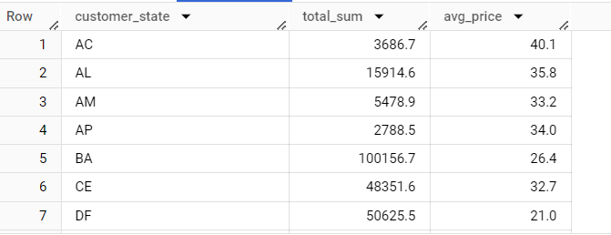

**Analysis based on sales, freight and delivery time:**

1. Find the no. of days taken to deliver each order from the order’s purchase date as delivery time.Also, calculate the difference (in days) between the estimated & actual delivery date of an order.

SELECT

    order_id,

    DATE_DIFF(order_delivered_customer_date, TIMESTAMP_TRUNC(order_purchase_timestamp, DAY), DAY) AS time_to_deliver,

    DATE_DIFF(order_delivered_customer_date,order_estimated_delivery_date,day) AS diff_estimated_delivery

FROM Target_Dataset.orders`;

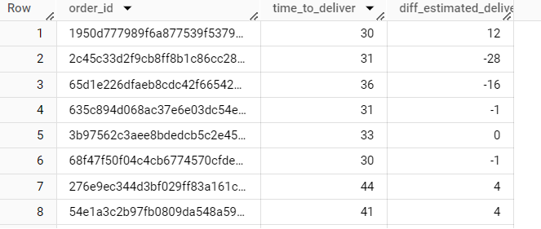

2) Find out the top 5 states with the highest & lowest average freight value.

    select c.customer_state,avg(freight_value) as max_freight

    from `Target_Dataset.customers` c inner join `Target_Dataset.orders` o on

    c.customer_id=o.customer_id inner join `Target_Dataset.order_items` oi on

    o.order_id=oi.order_id group by c.customer_state order by avg(freight_value) desc

    limit 5

    select c.customer_state,avg(freight_value) as min_freight

    from `Target_Dataset.customers` c inner join `Target_Dataset.orders` o on

    c.customer_id=o.customer_id inner join `Target_Dataset.order_items` oi on

    o.order_id=oi.order_id group by c.customer_state order by avg(freight_value) asc

    limit 5

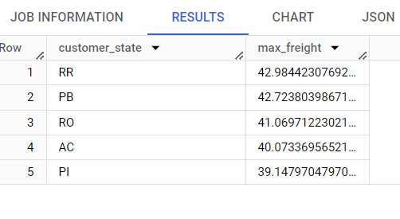

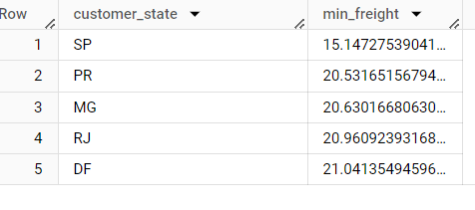

**Analysis based on the payments:**

1) Find the month on month no. of orders placed using different payment types.

  select extract(month from o.order_purchase_timestamp) as month,p.payment_type,

  count(distinct(o.order_id)) as count_of_orders

  from`Target_Dataset.payments` p inner join `Target_Dataset.orders` o

  on p.order_id=o.order_id group by 1,2 order by 1,2;

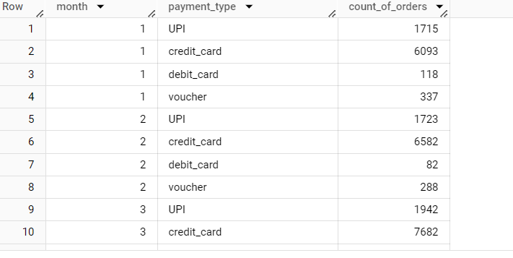

Observations made:

1)Target had improved its sales from the year 2016 to 2017,however there was a slight decrease in its performance in the year 2018.

2)Brazilian customers are more active during afternoon as they place huge number of orders.So improving marketing strategies,offers during these hours will have a positive effect on the company’s performance.

3)It is observed that target takes a lot of time to deliver products to its customers. Improving its delivery time will increase its customer base as they would prefer target over any other retail store with more delivery time.

4) It is also observed that credit card sales/payments play a major role .So connecting with more credit card companies and providing credit card offers/options have a higher chance of increasing its sales.